DTSC 671: AI Solutions in the Cloud

Sentiment Analysis with Amazon Comprehend

Goal
Your organization wants a cloud solution to determine the sentiment of reviews left on its website. Before integrating with the website, your task is to create a functioning solution in AWS that receives a review, analyzes the sentiment and then notifies a user in the organization by email.

In this assignment, you will upload a short review into an SQS queue, which will trigger a Lambda function. The Lambda function will call the Amazon Comprehend API to perform sentiment analysis on the review, then use SNS to send yourself an email with the review and the output from Comprehend.

Once your manager sees you have a functioning architecture, it will be refined to email only when the review is negative, most likely utilizing AWS Step Functions. Also, the first step (uploading the review to an SQS queue) will be integrated into the company’s website. We will not complete these steps in this lab.

You will submit the template with the requested screenshots on Brightspace. Please note you only have one submission attempt.

Architectural Overview





Upload review to SQS queue
SQS upload triggers Lambda function which uses Comprehend to perform sentiment analysis
Lambda sends review and sentiment analysis to SNS topic
User receives email from SNS with review and sentiment analysis

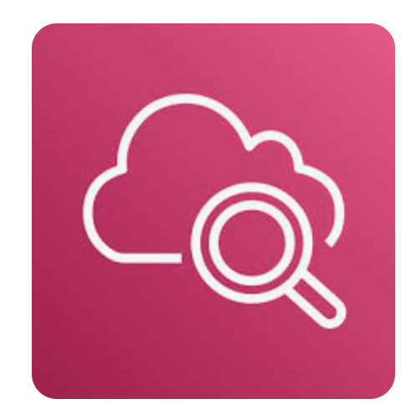
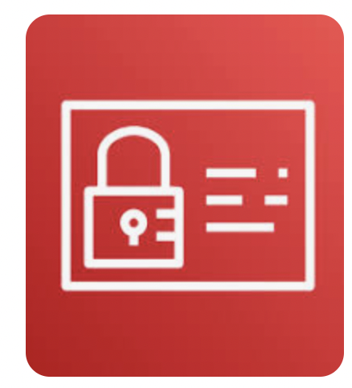
IAM role enables Lambda to create CloudWatch log to track activity
IAM role gives Lambda the permissions to retrieve text from SQS and call Comprehend API

Pricing Estimate
The following estimate shows the costs you may incur on your AWS personal account.

AWS Pricing Estimate
Service | Calculation | Cost
SQS requests | First 1 Million Requests per Month  Note: Each 64 KB chunk of a payload is billed as 1 request (for example, an API action with a 256 KB payload is billed as 4 requests). | Free tier
Standard SNS Topic | API Requests: First 1 million Amazon SNS requests per month are free, $0.50 per 1 million requests thereafter  Note: Each 64 KB chunk of published data is billed as 1 request. For example, a single publish with a 256KB payload is billed as four requests.  Notification deliveries: First 1,000 emails free; $2 per 100,000 thereafter  Data Transfer Out: First 9.999 TB per month: $0.09 per GB | Free tier
Lambda | Lambda assumption:  - Memory allocated: 128 MB  - Execution time MP4-to-JSON: 1319.8 ms (billed + initial)  - Requests: 1  - GB-seconds: (128 MB ÷ 1024) × 1.3198 sec = 0.165 GB-sec  Lambda pricing:  - Free tier: 1M requests & 400,000 GB-seconds/month  Cost Calculation (if beyond free tier)  - Cost: 0.165 GB-second × $0.00001667 = $0.00000275 | Free tier
Comprehend use in Lambda function | NLP API requests are measured in units of 100 characters (1 unit = 100 characters), with a 3 unit (300 character) minimum charge per request.  Amazon Comprehend offers a free tier covering 50K units of text (i.e., 5M characters) per API per month. | Free tier

Note about charges: Be sure to unlink your Lambda function from the SQS queue. The Lambda function will continually be accessing the queue to see if new messages have landed, which could inflate costs.

Directions
Make sure that all your services are in the same region (e.g., us-east-1)
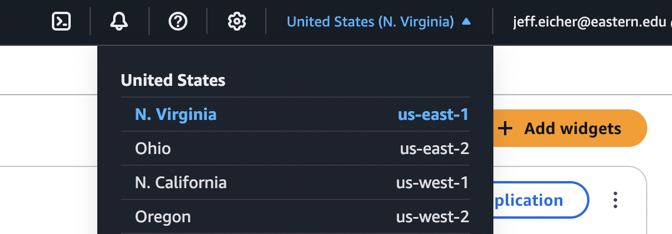

STEP 1: Create the SQS queue
- Navigate to Amazon SQS in the AWS Management Console.
- Select “Create queue”.
- Leave “Standard” as the default queue and name your queue: website-reviews-queue-<name>, for example, website-reviews-queue-jeffeicher
- Leave the other defaults. Add a tag with a key-value pair of dtsc-671 and comprehend.
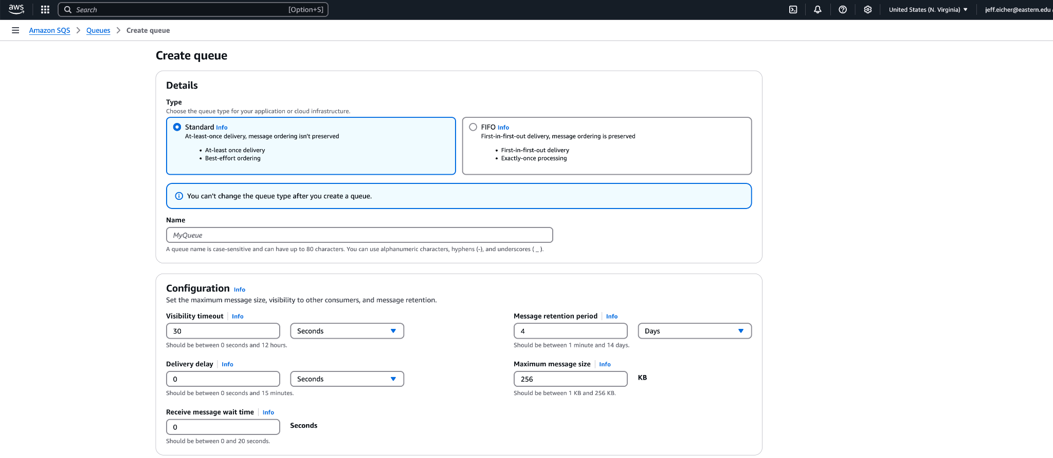
- Select “Create queue”.

STEP 2: Create the SNS topic
- Navigate to Amazon Simple Notification Service (SNS) in the AWS Management Console, type a topic name like website-review-email, and select “Next step”.
  - (Be careful in this lab - there’s SQS and SNS, which look similar!)
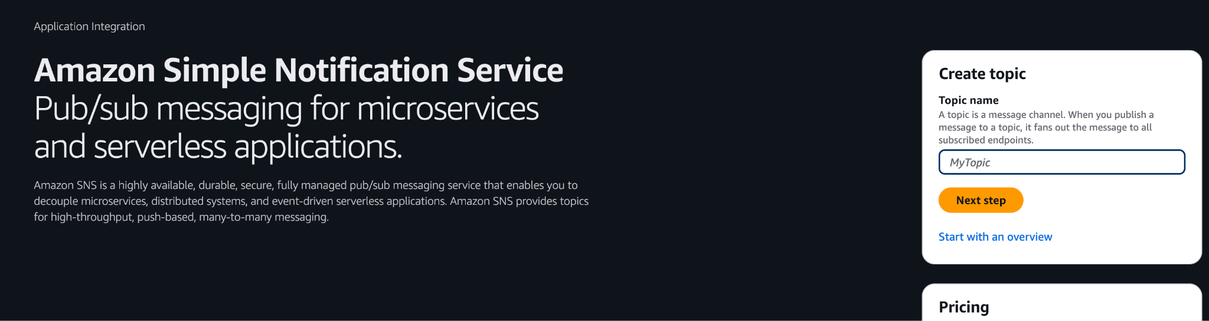

- Select “Standard” (no need for FIFO). The “Name” should automatically be the topic name you chose above. For the “Display name - optional”, let’s make it “You have a new review! (this will be the subject line of the email that is sent).
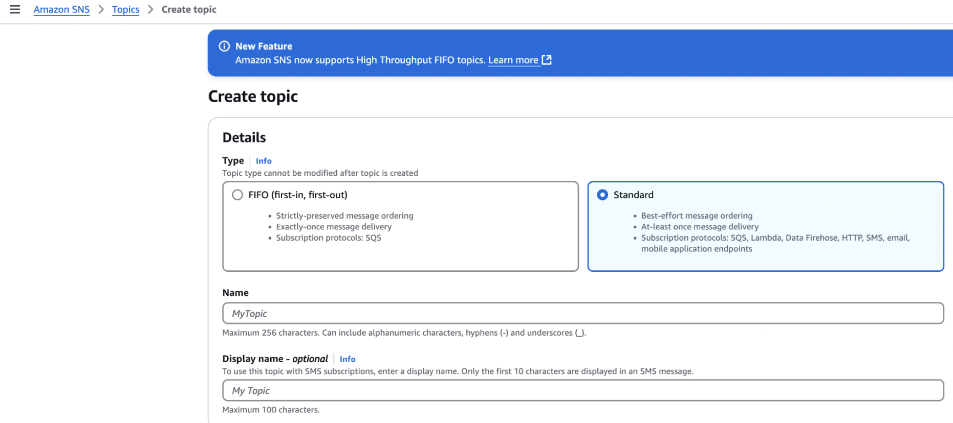
- Add a key-value pair tag like we did with SQS above.

- You can ignore all other settings; select “Create topic”.

- Go to the hamburger menu on the upper left (i.e., the three vertical lines) and select “Subscriptions”. Then select “Create subscription”.

- Complete the following:
  - Topic ARN: select the SNS topic you just created
  - Protocol: select “Email”
  - Endpoint: Type your Eastern gmail address
  - Select “Create subscription”.
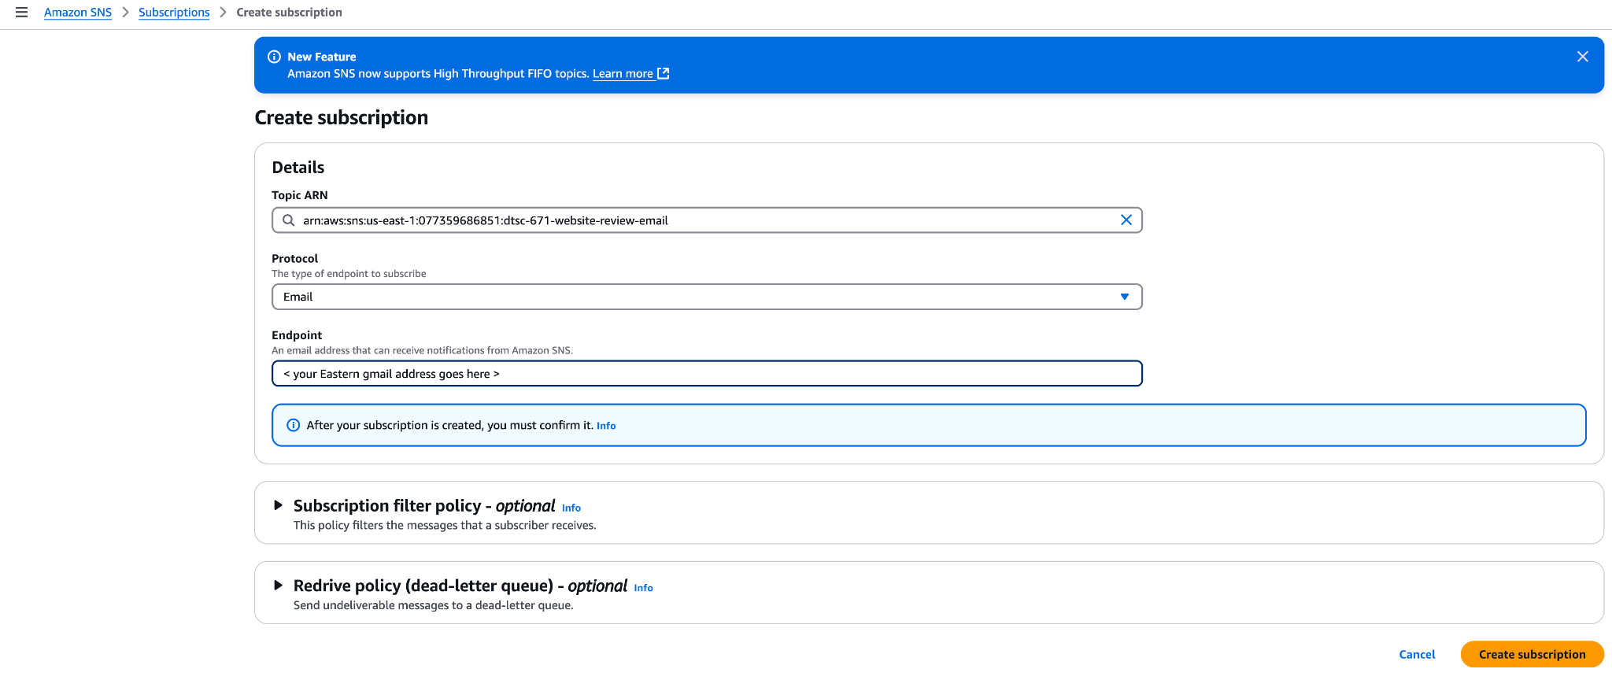

- Under the Subscription tab, You should now see a subscription listed with your email address. You will see “Pending confirmation” until you click the “Confirm subscription” in the email that was sent to your inbox.
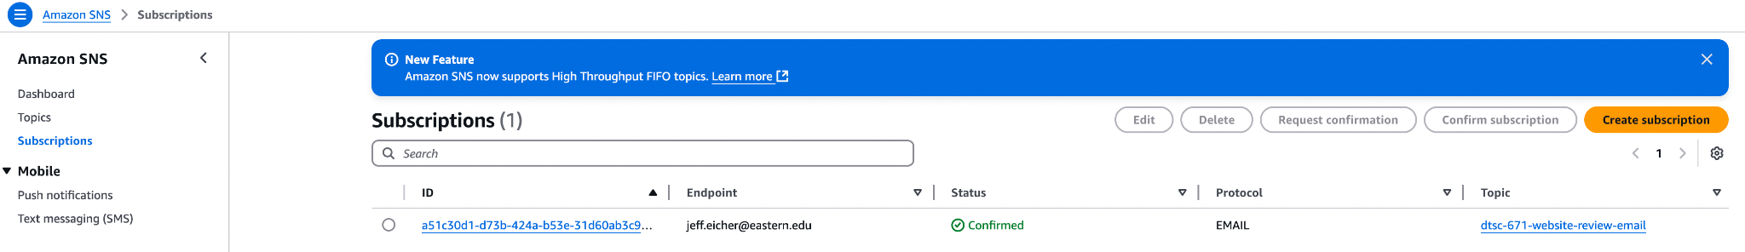
- Navigate immediately to your email and CONFIRM the subscription; you may have to look in your spam folder. The email will look like this; select “confirm subscription”.
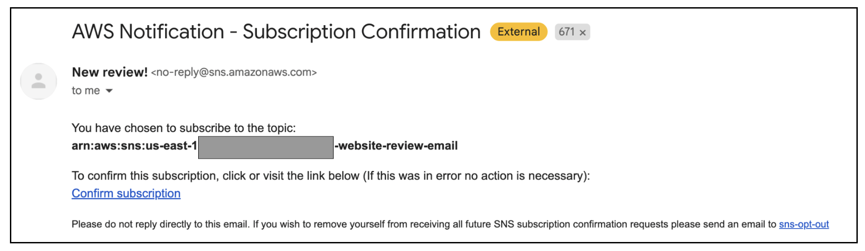

STEP 3A: Create Lambda function
- Create a Lambda function with the name: website-reviews-analysis-function-<name>
  - For example, website-reviews-analysis-function-jeffeicher
  - Use Runtime: Python 3.13
  - Create a new role with basic Lambda permissions
  - Include tags with the key-value pair as dtsc-671 and comprehend, respectively

How do I create a Lambda function?
Tutorial: How do I create a Lambda function?

STEP 3B: Configure Permissions for Lambda function
The role must have basic lambda permissions (which includes CloudWatch logging), SQS polling, publishing to SNS, and calling the Amazon Comprehend API.

- Select “Configuration,” then “Permissions.”
- Add permissions to this role, including the AWS managed policy ComprehendReadOnly and SQSFullAccess, and SNSFullAccess.
  - We need the API actions of "sqs:DeleteMessage", "sqs:GetQueueAttributes", "sqs:ReceiveMessage", "sns:Publish", but we will use FullAccess for ease of use.
  - If you decide to follow the principle of least privilege to create a policy to allow access to publish to the SNS topic with the API call "sns:Publish" on the SNS topic you created as the resource, make sure you use the SNS topic ARN as the resource, not the subscription ARN. It should look like this: Arn:aws:sns:<region>:<account>:website-review-email (without numbers/letters after topic name)

How do I add permissions to an IAM role?

Tutorial: How do I add permissions to an IAM role?

STEP 3C: Configure Lambda function
- In the diagram, select “+add trigger”. Select SQS as the source.
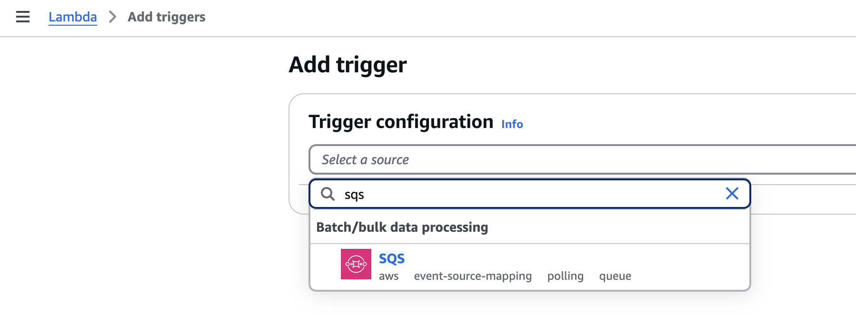

- Under “SQS queue”, select the queue you created earlier. By default, “Activate trigger” should be selected. Note: When you are not working on this assignment, I recommend deselecting this option to reduce the chances of incurring unexpected charges.
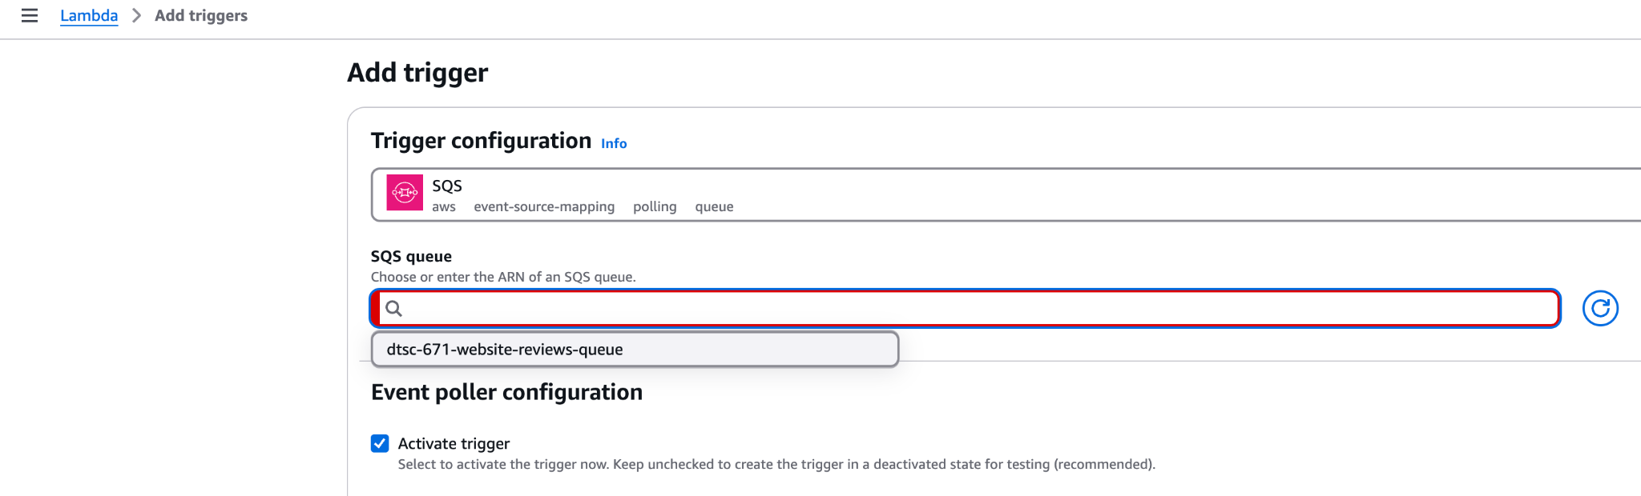

- Under “Additional settings”, include a key-value tag. 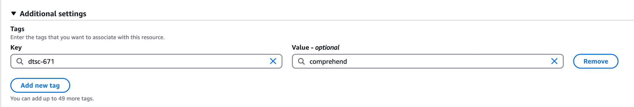
- Save the trigger configuration.

- In the Lambda diagram, select “+add destination”. For “Destination type,” select SNS topic. For “Destination,” select the SNS topic you created earlier in this assignment.
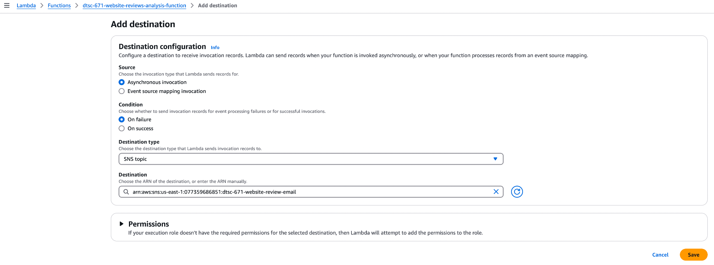

- You should now have this diagram (the name of the Lambda function will differ).
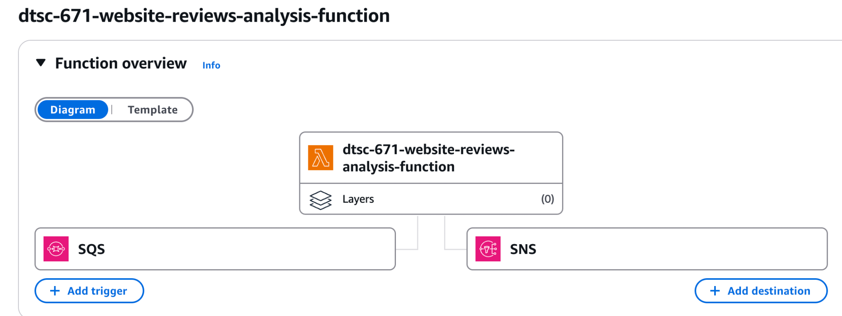

- Under the “Configuration” tab, select “General Configuration” on the left. Change the “Timeout” from 3 seconds to 1 minute. Everything else can remain the same. Select “Save”.
- Under the “Configuration” tab, select “Environment variables” on the left. Make SNS_TOPIC_ARN an environment variable, so you don’t have to hard-code your SNS topic ARN into your Lambda code. Copy and paste the SNS destination in the value textbox, which looks like this arn:aws:sns:<region>:<accountnumber>:dtsc-671-website-review-email.
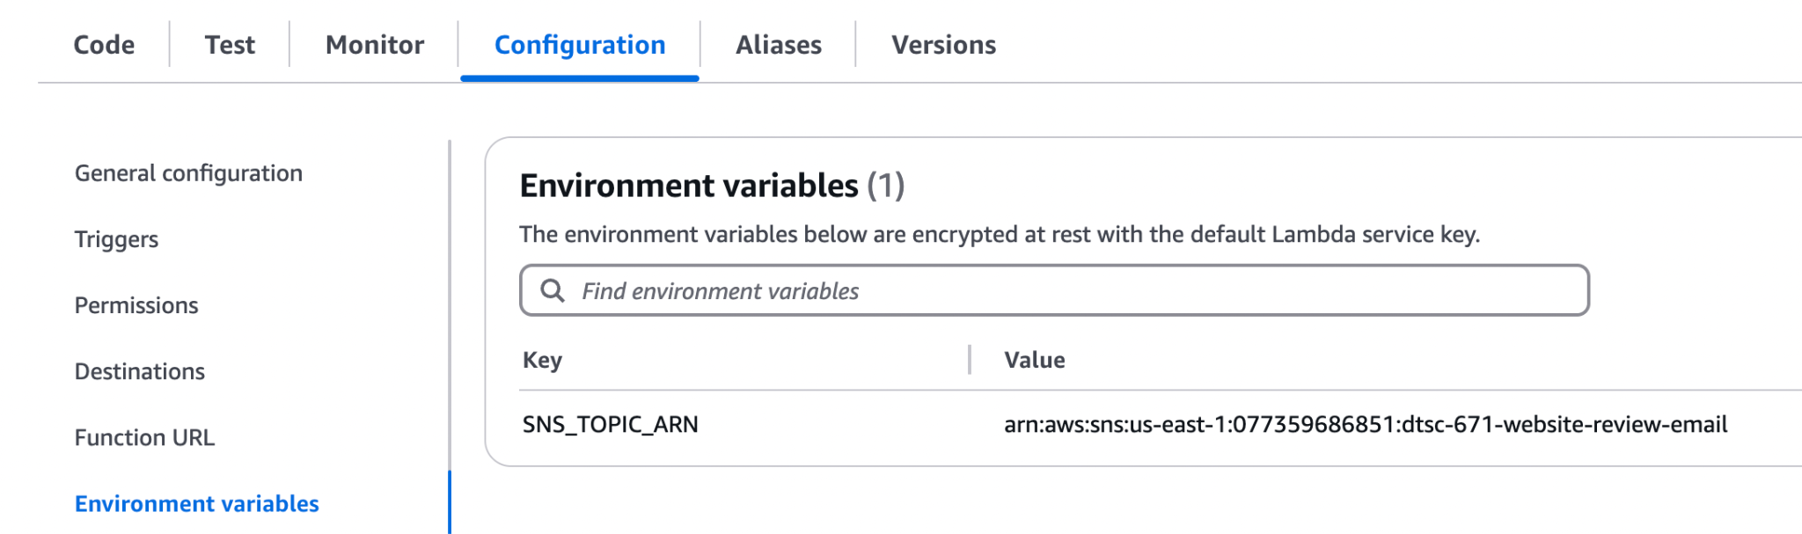

STEP 4: Write code for Lambda function and deploy
Guidance and Tips
- We encourage you to use an LLM (like ChatGPT, Gemini, etc.) to help you write and debug the code for your Lambda function
  - We recommend not trying to have your Lambda function do “too much” at once.
  - When writing prompts for an LLM, ask the LLM to include error handling to help you diagnose issues with your code or architecture.
  - Give the LLM information such as your Runtime (i.e., Python 3.13)
- Include print statements through your code to help troubleshoot.
- In this assignment, you'll use the Amazon Comprehend API method detect_sentiment in your code. Here is the relevant documentation.
- Anytime you make edits to your code, be sure to hit “Deploy”; otherwise, your updated code will not run.
- Wait until the green banner shows the function has been deployed before moving on.

STEP 5 Test Lambda: Upload text to SQS
- Navigate to the SQS and select the SQS queue that you created at the beginning of this assignment. (Click on the hyperlink, rather than the circle next to the name.)
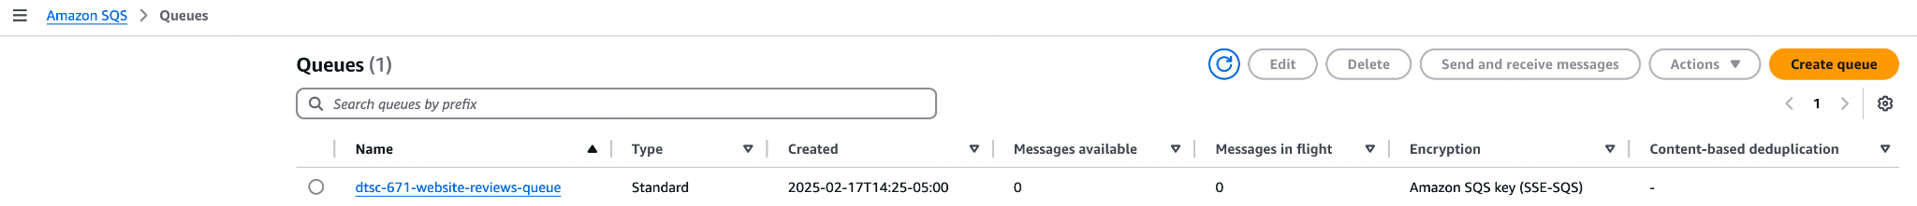

- In the upper right of the queue menu, select “Send and receive messages”.
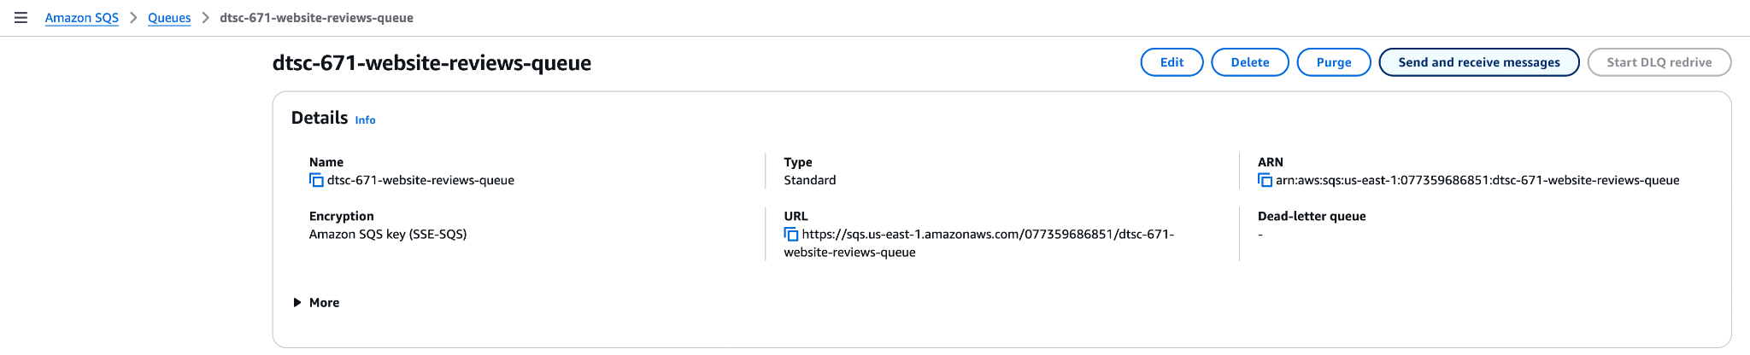

- In the next menu, under “Message body”, type a review (a few sentences) for a review of a business or product. Or, you can find a review for a business or product online, if you’d like.
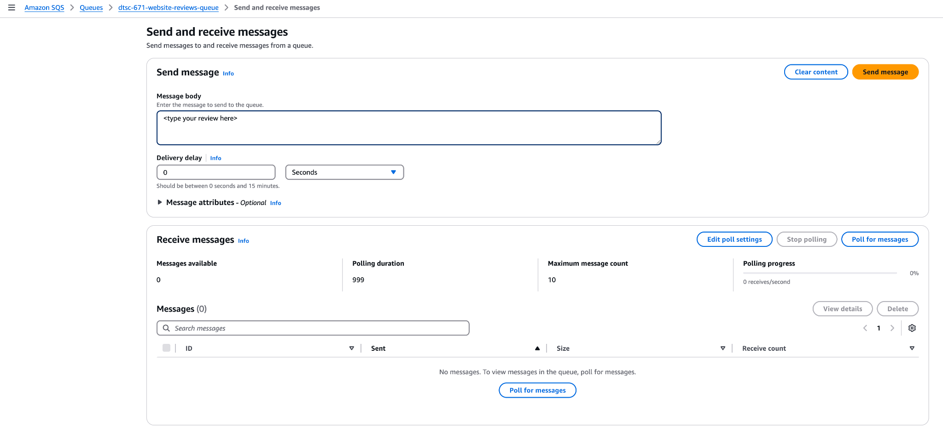
- Select “Send message”, which will trigger the Lambda function (if everything is set up correctly!) Keep a copy of the review for your records when you submit this assignment.
- Under the “Receive messages” section, select “Edit poll settings” and make the polling duration 999 seconds. We change this to the maximum of 999 seconds (16.65 minutes) to reduce the number of times Lambda may poll SQS for new messages and incur costs.
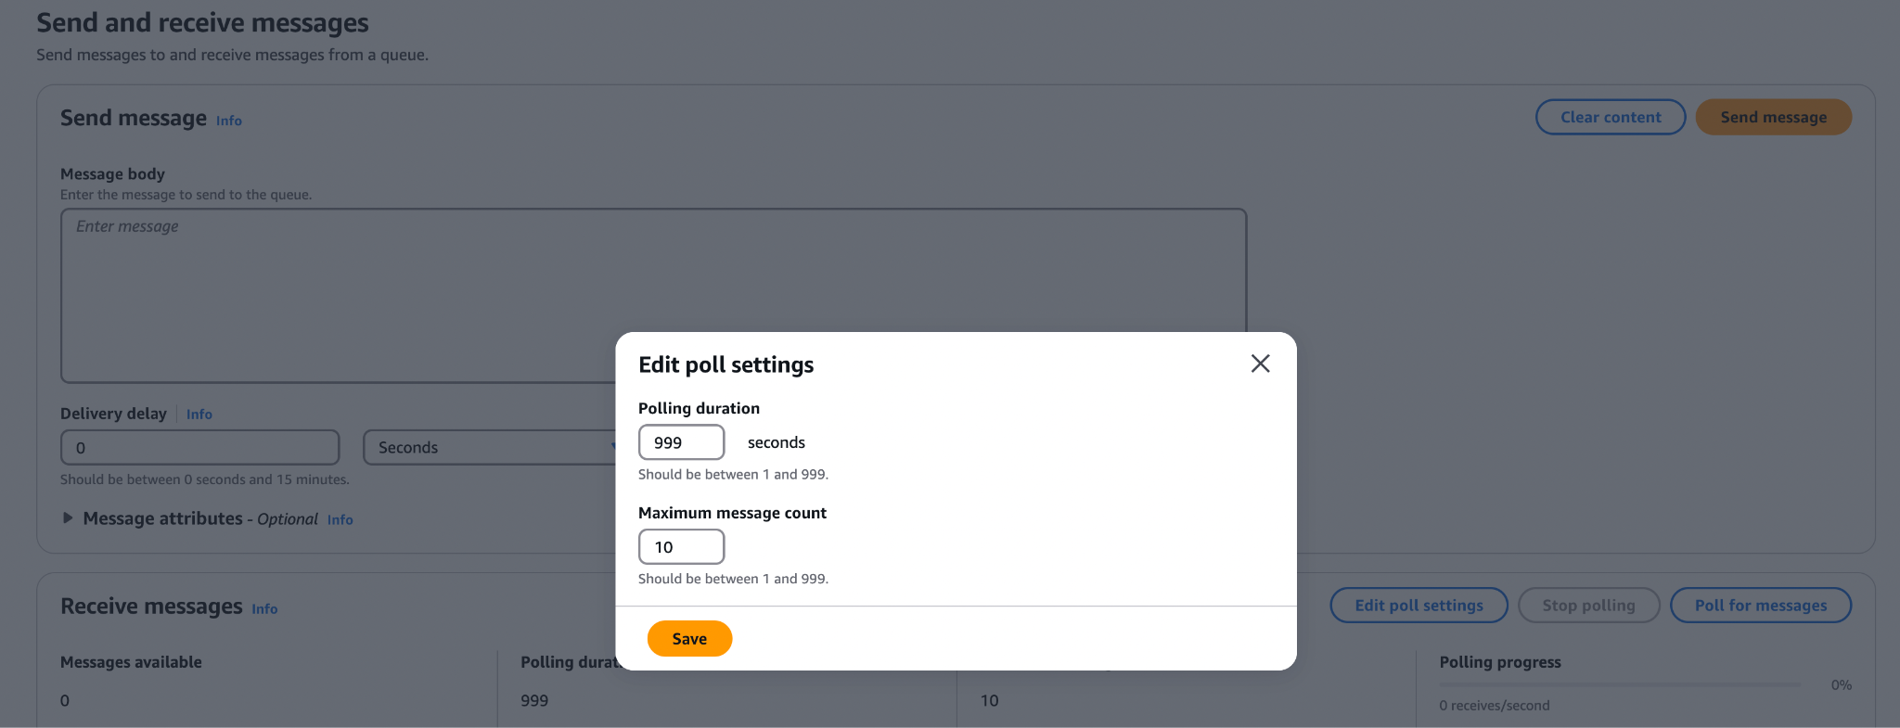

STEP 6: Was the Lambda successful?
There are two ways to check if the Lambda code is functioning correctly.
- Did you receive an email with the text of the review and the sentiment analysis (positive, negative, or neutral)?

- You can go to the “Monitor” tab in your Lambda function, and select “View CloudWatch logs”. Check the most recent CloudWatch stream in this log for any errors.

Note: If your IAM permissions are not set correctly, you will not see any cloudwatch logs for this lambda function.
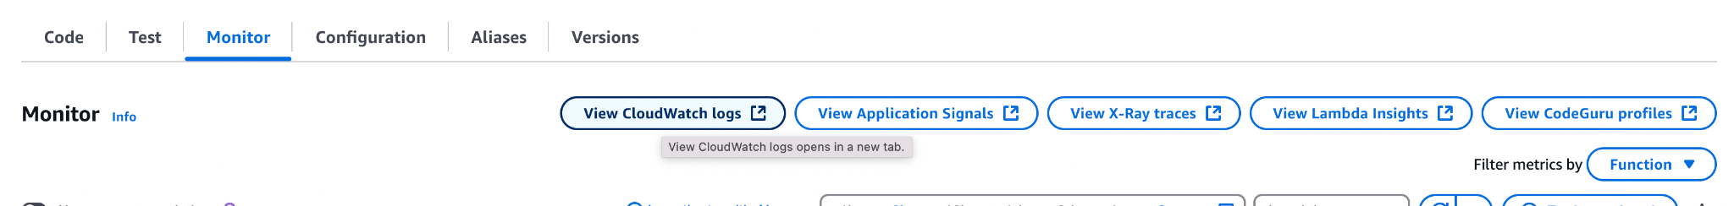

- If the function did not work as expected, see below for troubleshooting ideas

STEP 7: Troubleshoot

- How do I use CloudWatch logs to troubleshoot my code and architecture?

- Use an LLM to troubleshoot
  - When writing prompts to develop your code, ask the LLM to include error handling to help you diagnose issues with your code or architecture.
  - Give the LLM information such as your Runtime (i.e. Python 3.9)
  - The LLM will likely give you a list of error possibilities. Work carefully through each one. If there’s still an error, let the LLM know what you did to fix any issues.
  - After you have tried troubleshooting with an LLM, if you email the GAs or professor, you must include screenshots of your architecture and error messages.

- Resubmit your review in the SQS queue. This action will trigger the lambda function to run again. If it still does not provide an email of the review and sentiment analysis, continue troubleshooting.

- What information does the professor or GA expect in order to assist you?
  - Helping you is much different than classes with CodeGrade—we can’t simply jump into your AWS account and troubleshoot!
  - We expect one or both of the following:
    - Screenshots of your architecture, following each step above, so we can find where the issue may be
    - A video showing your architecture, including the error messages in CloudWatch.
  - An email that says “my lambda function is not working” is not sufficient and is not helpful
  - Do not post your lambda function code on the discussion boards. All other information and questions can appear there.

STEP 8: Brightspace submission
- Download the assignment template with requested screenshots as a PDF document (File > Download > PDF Document). Submit your template PDF to the Brightspace assignment.

This is course material that was distributed to students enrolled in DTSC 671 at Eastern University. The materials were made exclusively available to students solely for the purpose of completing the course and are not intended for further distribution or retention beyond the course period. The materials were created by program faculty specifically for use in courses at Eastern University.

